Current situation in the region and implementation of the project “Your Job”
According to the statistics of Civil Registry’s office, the municipality of Lezha population has registered 110,000 citizens. Based on this statistic, the age group between 15 and 30 years produce 21.4%, where is a considerable number of them failing in education (including here even the high school), because only 20% of them have the possibility to go in University (Bachelor/Master). Lezha has shortage about the universities and has only one vocational school, which also doesn’t have any engagement, as a cause of orientation’s deprivation to youngsters after finishing the compulsory education. While population in Kurbin’s municipality based on Civil Registry’s office is 75,000 and the age group between 15-30 years it’s higher reaching 22.1%. The same situation is in Kurbin, where they’ve shortage about the universities, but also in vocational school, so after finishing the compulsory or high school education, unemployment or migration is the only choice for them.
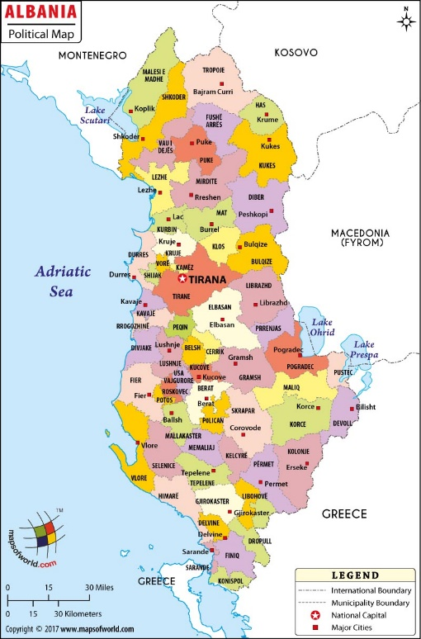
The visibility of these statistics arises as needed to implement “Your Job” project to motivate and orient this youngsters group, which are the future of country. We find it necessary to help young people towards their path of employment and stability in the country. According to Eurostat statistics, Albanians rank second behind Syrians in asylum’s applications of EU countries. Or worse they tend to the bad and deviant habits of society. Destabilization, informality and political crises, have buried the motivation for employment and professional growth.
The project "Your Job" comes as an immediate need for young Albanians. This project aims to empower youngsters in need on personal and professional aspects, to continue their social and economic development, abandoning poverty. The project is implemented by Caritas Albania, applied by Caritas Austria and is financially supported by ADA (Austrian Development Agency).

Through the Entrepreneurship component, the project supports youngsters group to develop their entrepreneurial skills, conceptualizing and building on professional or business initiatives, through the following initiatives:

The project will have direct benefits on youngsters, but also indirect benefits on their families, residents of Lezha/ Kurbin and on local businesses that will have qualified employees. Youngsters group of KF-Laç (Kurbin) fan club are committed to influencing project’s involvement with positive motivation and spirit. Also, the parishes are involved helping the project by uniting the youngsters to include on. Cooperation with Diocesan Caritas (Tirana- Durres) and Archbishop George Anthony Frendo, has become possible a fundraising video message (in English) for helping on implementing of others regions of Albania.

