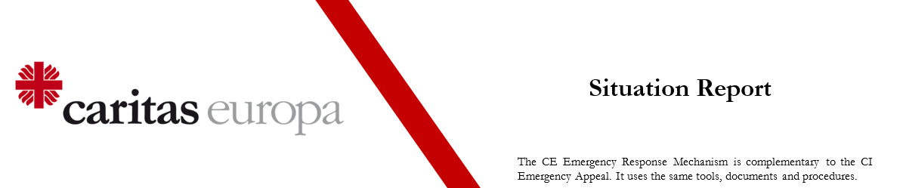

PROGRAMME TITLE: Relief After November Earthquake

PROGRAMME LOCATION: Albania

DATES COVERED: 26 November 2019

SITREP NUMBER: 1

SUBMITTED BY: Caritas Albania

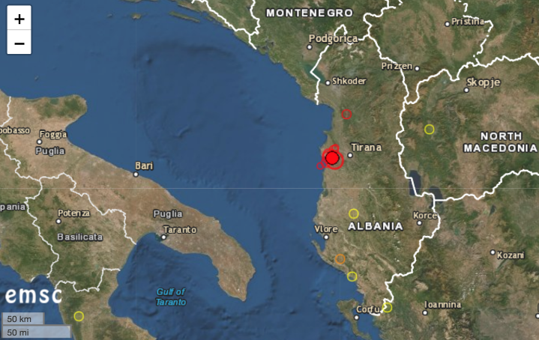
1. SITUATION OVERVIEW
- A 6.4-magnitude earthquake struck shortly before 4 am local time, followed by hundreds of sometimes important aftershocks. Minimum 650 people are injured and 22 died.
- More than 160 aftershocks happened since this morning and 3 of them have reach 5.4 – 5.3 and 5 Magnitude
- 41 people were rescued by relief teams during these hours from collapsed buildings.
- Hundreds of buildings and houses are not safe and habitable
- Two hotels in the city of Durrës collapsed.
- Different parishes and churches are damaged, mostly in the Diocese of Tirana, some in the Diocese of Lezhë.
- Caritas Albania has organised two teams to do field visits: a first team was in the periphery of Tirana and the second in Durrës and Thumanë.
- In the periphery of Tirana around 35 houses are damaged and people in are a panic, a church building and the house of nuns are damaged as well.
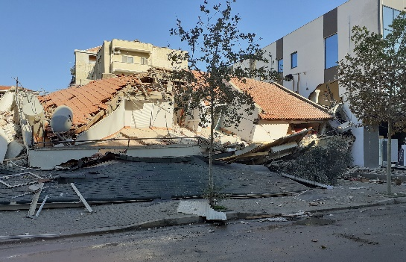
- The second team informed that in Durrës a six-floor building sank two floors down, in Thumanë, 5 buildings are damaged totally, which means that 45 families have lost everything. The local authorities in that village already talk about 10 deaths, so this number is expected to increase nationwide.
- People still missing under collapsed buildings.
- Authorities have deployed military and police to support the relief efforts.
- The government is starting to establish emergency shelters. Food support is one of the most urgent immediate needs. As the winter has already arrived other immediate needs are blankets and basic WASH.
- Foreign governments are already providing support: Civil protection teams from Kosovo, Italy, Greece and Romania have already arrived and participate mainly in search and rescue missions.
- Civil protection is preparing:
- 3 accommodation centres in Tirana
- 3 accommodation centres in Shijak – Durrës
- 1 accommodation centres in Helmes – Kavaje
- 1 open tent camp in Thumane
- 1 open tent camp in Durres (more than 1,000 families)

2. CARITAS RESPONSE

Ongoing activities:
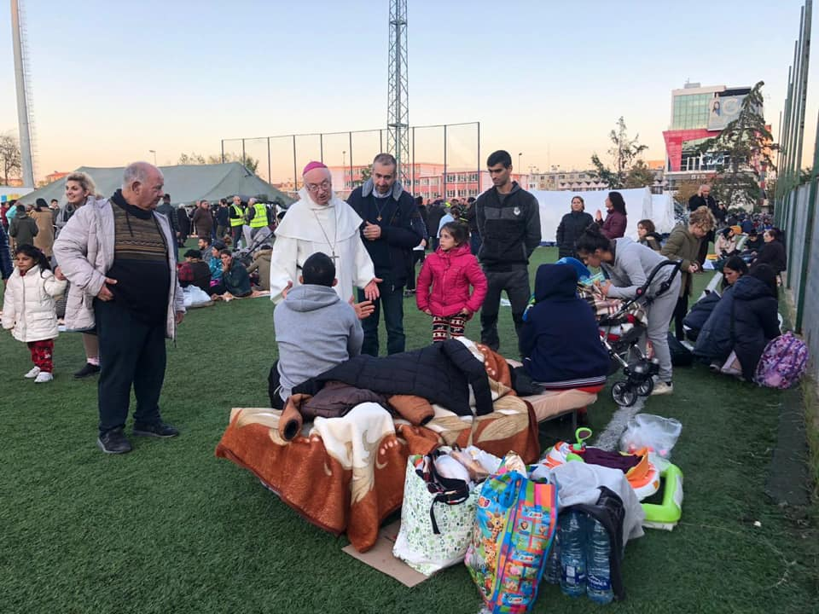
- Caritas Albania has visited some of the most affected areas on the day of the earthquake and started distributing food items (sandwiches) in Thumanë.
- Caritas Albania is in continuous contact with its network of collaboration for gathering of information about the situation, because the data and needs are changing permanently.
- Caritas Albania is using funds from two ongoing Emergency Response Programs to prefund first relief efforts.
- Caritas Albania has received the official request from the interior ministry for food and non-food items distribution for displaced people in the different accommodation camps mentioned above.

Needs identified:
- Shelter: many houses are either destroyed or not safe anymore, so that people cannot return to their homes. At the moment the government provides shelter in tents and in several accommodation centres (public buildings, often schools). Alternatives will be needed in both cases: tents will not be a proper solution during winter; public buildings like schools cannot be used as shelters for a longer period.
- Food: Since there are no cooking facilities in the provided shelters, ready-made food is needed for the first days; alternatives can be developed at a later staff.
- WASH: access to clean water, washing facilities, hygienic materials.
- NFI: there is an urgent need for blankets and bedding.
- There are signs that psycho-social support will be needed for a part of the affected population.
- Needs cannot be quantified at this moment, but further assessment will provide more exact information.

Next steps planned:
- Volunteer teams will distribute essential relief items in Durrës and Thumanë camps: ready-made food and blankets. Distributions will start on Wednesday, 27th November.
- Caritas Albania and the Diocese of Tirana – Durrës are preparing a youth volunteers involvement plan.
- The emergency team of Caritas Albania will continue its assessment, both at field level and by collecting information from parishes, other agencies and authorities.
- Based on the assessment and in coordination with its partners, Caritas Albania will develop further response plans.

Support from the Caritas network:
- A team from Caritas Kosovo arrived on 26th November and will support Caritas Albania
- Daniele Bombardi from Caritas Italy arrived on 26th November in the evening to support Caritas Albania staff.
- CRS already re-allocated 15,000 EUR from a previous project to be used and will send Marie Miano to support Caritas Albania to develop a project proposal. European Caritas also agreed that funds from ongoing Emergency Response Mechanism projects should be used to pre-finance first relief efforts.
- Caritas Hungary offered sending their emergency rescue team for support but since responsibility for search and rescue is exclusively with the government, Caritas Albania will inform the authorities about this offer.

3. COORDINATION

- The Civil Protection Department under the Ministry of Defence is responsible for coordination at a national level. At the local level head of districts are responsible and organise emergency committees operating locally. Caritas Albania is in contact with all levels: civil protection, heads of districts and local committees.
- Caritas Albania works in close contact with the representatives of Caritas Italy in Albania and is in regular contact with Caritas Europa.
- Different Italian congregations are in contact with the representative of Caritas Italy in Albania.
- Neighbouring Caritas offered support: Caritas Kosovo is gathering NFI to be distributed with Caritas Tirana.
- Misericordia di Firenze plans to send some materials that will arrive on 26 November 2019.
- In Thumanë, Caritas Albania was in contact with World Vision, distributing blankets, and the Qatar foundation, distributing water.
- The cement factory in the municipality of Fushë Kruja offers the food for this first day for Thumanë Camp.

4. MEDIA AND COMMUNICATIONS

Find information, pictures and videos, please see the website and the Facebook page of Caritas Albania:
- http://caritasalbania.org/
- https://www.facebook.com/CaritasShqiptar/

5. PLEDGES AND CONTRIBUTIONS
- CRS agreed to re-allocate 15,000 EUR.

6. KEY CONTACTS

- Enkelejda Qama, Project Manager, +355 4 223 0088, + 355 69 70 41303, e.qama@caritasalbania.org
7. NEWS ARTICLES

- The Guardian: Albania earthquake: at least 21 dead and hundreds injured + Destruction and panic as quake hits Albania – in pictures
- DW: Albania: Biggest earthquake in decades takes deadly toll
- BBC: Albania hit by deadly 6.4 magnitude earthquake
- Euronews: More than 21 dead following Albania's strongest earthquake in decades
- CNN: At least 23 killed as 6.4-magnitude earthquake strikes Albania
- The New York Times: Albania Earthquake Kills at Least 23
- Tageschau: Tote bei Erdbeben in Albanien
- Neue Züricher Zeitung: Erdbeben der Stärke 6,4 erschüttert Albanien – die Zahl der Todesopfer steigt auf 23, Hunderte von Verletzten
- La Republicca: Terremoto in Albania: forti scosse continue, la più colpita Durazzo: almeno 23 morti e 600 feriti

8. PHOTOS

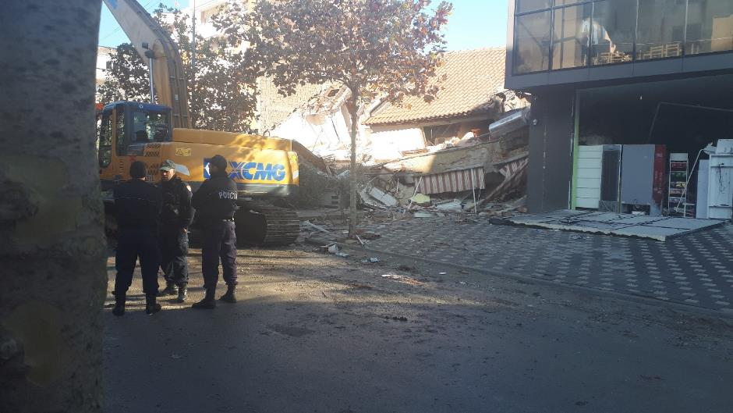
Security forces have been deployed while the relief efforts and clearing up works are going on.
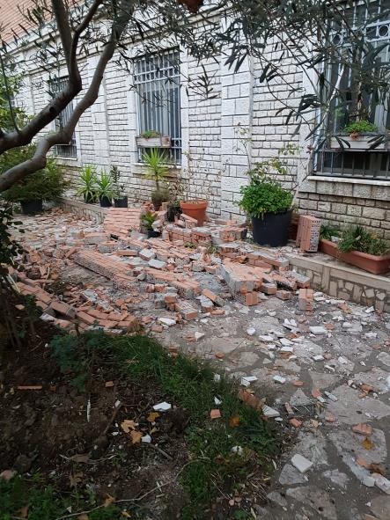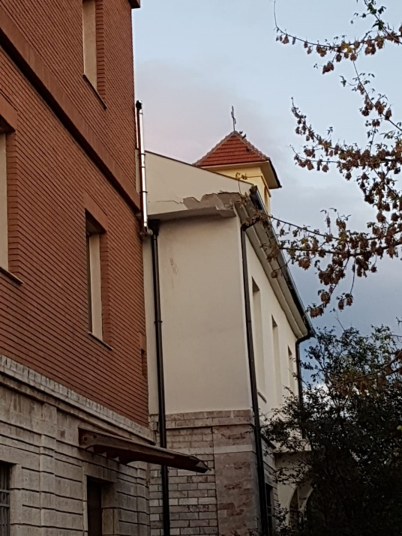
Many houses that did not collapse were also damaged, here in Shënkoll.

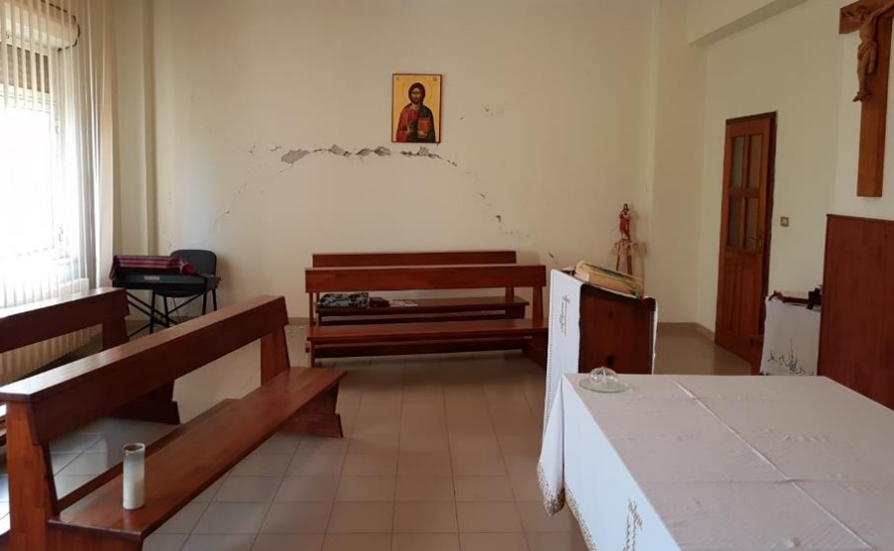
The cracks on the wall of this prayer room in Shënkoll were caused by the earthquake and its aftershocks.

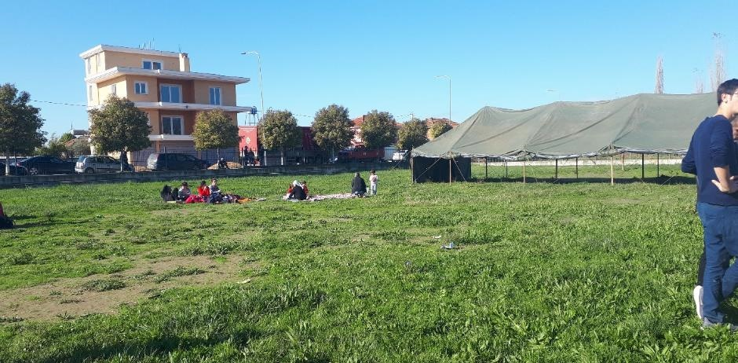
Many people are traumatised are prefer to stay in wide open spaces (Thumanë).
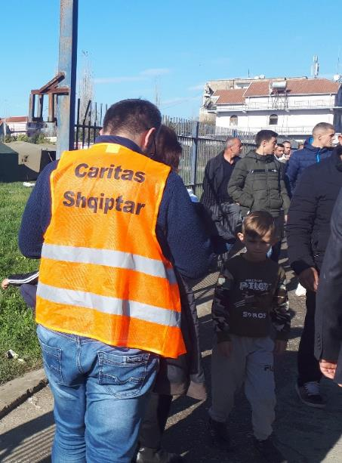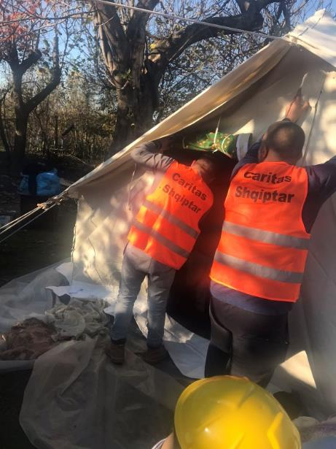
Thumanë was the most heavily affected by the earthquake. Caritas Albania staff and volunteers is at the side of the local community.

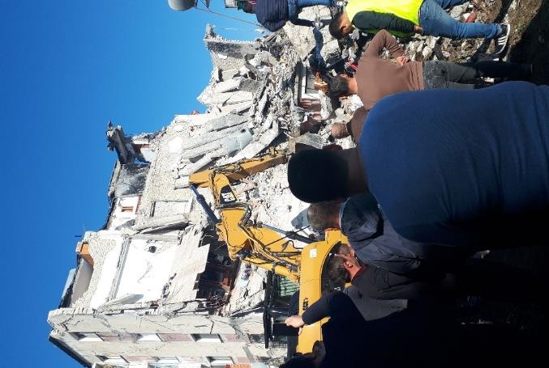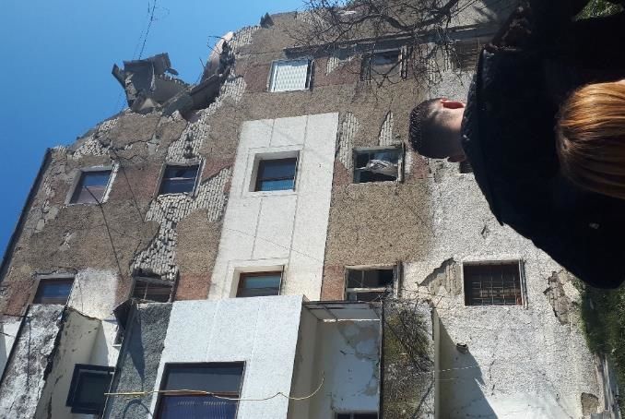
The houses in Thumanë suffered various degree of damage, from total destruction to light damage.

